MACH4METAL

metalworking machinery
Bank No : 66.52.13.883
IBAN : NL33 INGB 0665 2138 83
BIC : INGBNL2A
VAT : NL 815393635B01
Transito 21, 6909 DA Babberich, Netherlands
Tel. + 31 (0)316 – 247123
Fax. + 31 (0)316 - 247956

PUMA 280 M

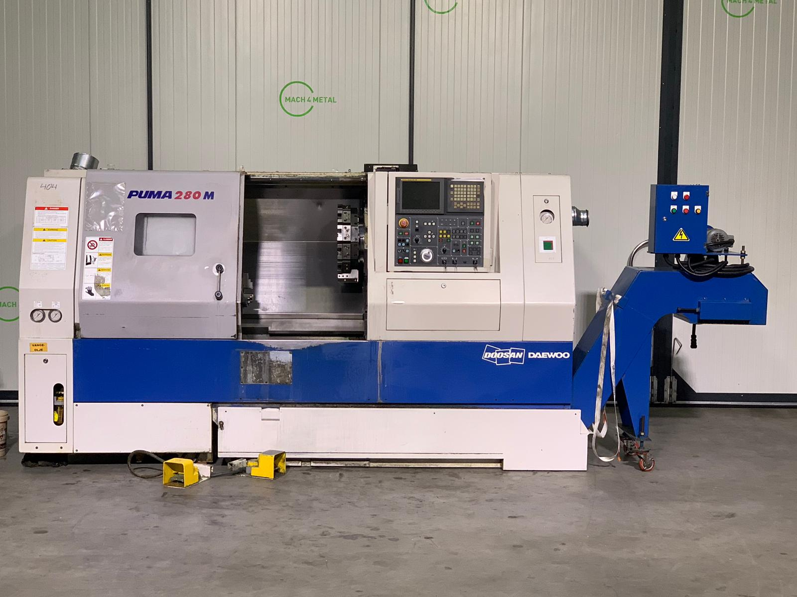
- Make : DAEWOO DOOSAN
- Type : PUMA 280 M
- Age : 12. 2006
- Serial : 0098

- Swing over slide Ø : 630
- Swing over bed : 500
- DBC turning length : 658
- Spindle bore : 76

- Spindle speeds Rpm : 3.500
- Spindle main power Kw : 18.5/22
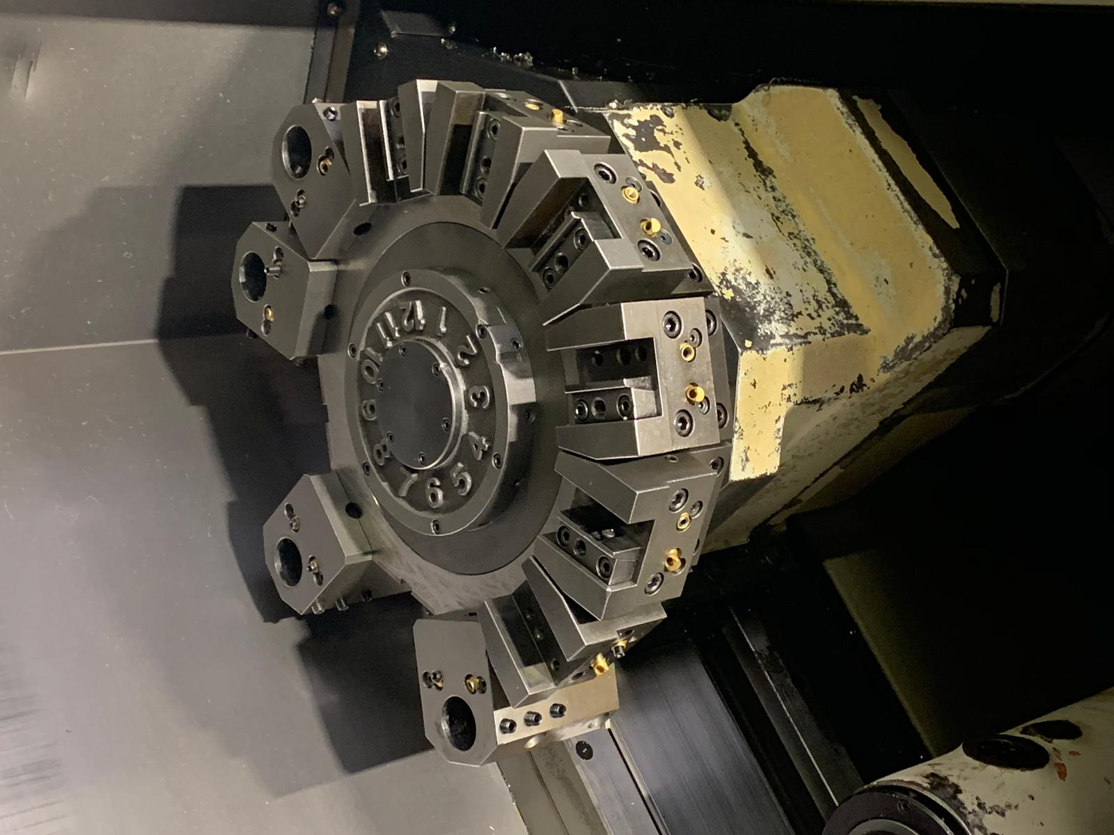
- Travel X slide : 242
- Travel Z slide : 680
- C Axis : 360 Gr.

- Rapid Feed : X 20.000
- Rapid Feed : Z 24.000

- Spindle taper : Mk 5
- Quill travel : 100
- Quill diameter : 100
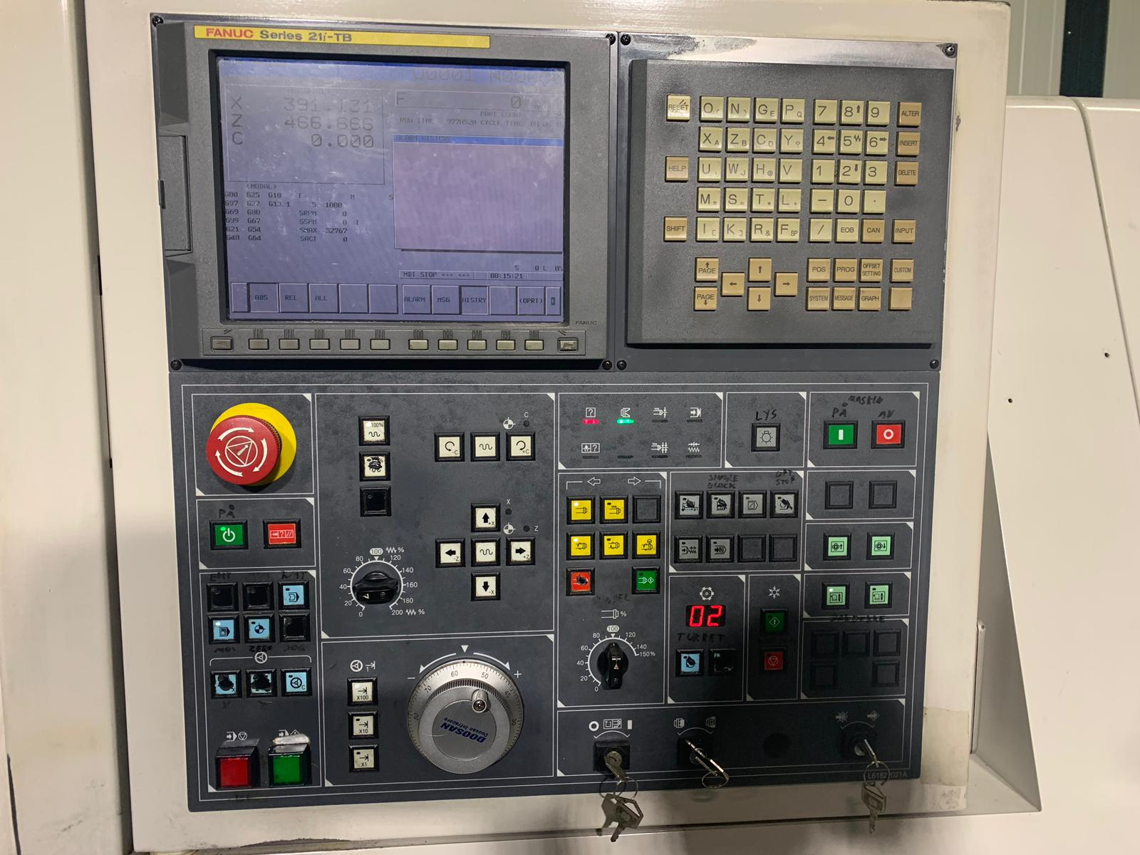
- Revolver number station : 12
- Live tool speeds : 5.000
- Power tools : 5.5 kW

- Fanuc 21 i-TB
- Tool eye
- Kitagawa chuck
- Length : 3.420
- Width : 1.700
- Height : 2.000
- Weight : 4.900

Please Note: The above information has been obtained to the best of our ability and belief from, and from the manufacturers where possible. It is given in good faith, but its accuracy can not be guaranteed. Accordingly, it will not form a representation or constitute contractual terms. We advise you to check any vital details!

